THE CORE OF INCIDENT COMMAND SYSTEM FOR SCHOOLS
I.M.O.P.
- ( I )nformation and Intellegence (Situational Awareness)
- (M)anagement (Leadership – Who is in charge)
- (O)bjectives – (Things that need to be done)
- (P)riorities – (In what order)

- Life Safety
- Incident Stabilzation
- Property / Enviornmental Preservation

I.M.O.P.
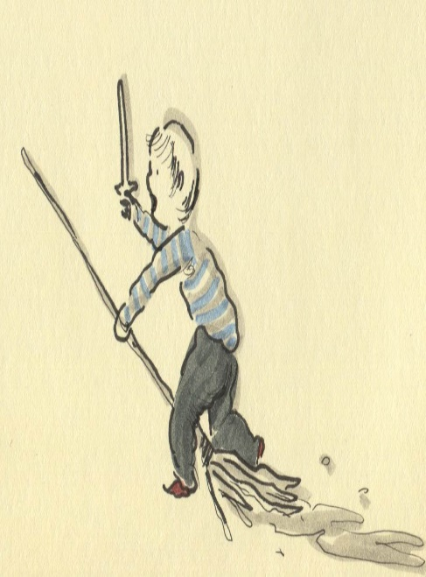

Duties and Responsibilities Schools Should Consider When Responding To An Incident:
- Unified Incident Command Representative - Expectations
- Search and Rescue Team(s)
- First Aid Team(s)
- Facility and Security Response Team(s)
- Evacuation / Shelter Team(s)
- Crisis Intervention Team(s)
- Student Accountability – Reunification Team(s)
- Public Information Officer

Trying To Make Sense Of It All Training Available - Upon Request:
Mark Feddersen, North Safety Analyst for the Idaho School Safety and Security Program – email – mark.feddersen@osbe.idaho.gov

